ABSTRACT

Steganography is the art and science of communicating in a way which hides the existence of the communication. The goal of steganography is to hide messages inside other "harmless" messages in a way that does not allow any "enemy" to even detect that there is a second secret message present. However, really good steganography is very difficult to implement and usage of most of the currently available steganographic crackers can quite easily detect an encrypted data. I will be using “Two-Level Authentication”, 1.Encryption Key 2.Validation Code for encryption reasons. This project does not deform the original content of the file i.e. there will be no color variation in image files. This has been the major drawback in the conventional Image Steganography.

My project will be mainly based on Visual Basic. This project can be implemented on any non-editable files also such as EXE etc and also on compressed image files such as JPG which is very difficult to implement in standard steganography methods.

There will be high-level of security since there will be 2-level authentication, one being “Encryption Key”, which will be the combination password to the original message. The message will be converted to ASCII value and added to the ASCII value of the Encryption Key. Second being the “Validation Key”, which being the position of the encrypted text in the image or the data files.

CHAPTER 1

INTRODUCTION

Steganography, the art of hiding messages inside other messages, has until recently been the poor cousin of cryptography. Now, it is gaining new popularity with the current industry demands for digital watermarking and fingerprinting of audio and video.

What are watermarking and fingerprinting? Through the use of advanced computer software, authors of images, music and software can place a hidden ``trademark'' in their product, allowing them to keep a check on piracy. This is commonly known as watermarking. Hiding serial numbers or a set of characteristics that distinguishes an object from a similar object is known as fingerprinting. Together, these two are intended to fight piracy. The latter is used to detect copyright violators and the former is used to prosecute them. But these are only examples of the much wider field of steganography. In this paper, we aim to present a general introduction to steganography, or data hiding, as it is sometimes just known.

When examining these data-hiding techniques, we bear in mind specifications, such as degradation of the cover data must be kept to a minimum, and the hidden data must be made as immune as possible to possible attack from manipulation of the cover data.

Steganography in images has truly come of age with the invention of fast, powerful computers. Software is readily available off the Internet for any user to hide data inside images. The most popular technique is Least Significant Bit insertion, which we will look at. Also, there are other methods such as masking and filtering, and algorithms and transformations, which exploit the human eye's weakness to luminance variation
CHAPTER 2

PROBLEM DEFINITION AND FEASIBILITY
ANALYSIS

2.1 Problem Definition:
In this project, we will first study the steganography methods available for image files. Then we will attempt to implement one algorithm to hide a message, encrypted with a key, in an image file, so that it can only be decoded using the same key.

2.1.1 Problem Statement:
To add security / encryption to a message embedded in an image file using Visual Basic. The main objective of our project is to provide the following features:
- Message Encryption: To hide the data in the image file with a satisfactory level of encryption.
- Image Integrity: To attach the encrypted message in the image, without any perceivable change in the image.
- Message Extraction / Decryption: To extract the encrypted hidden data from the image.

2.1.2 Present Status of the Problem:
Though quite a few products exist in the market where they give a satisfactory level of encryption to the message using the general procedure of information hiding, there are “Steganography Image Crackers” to extract the hidden encrypted message and either descramble or brute-force the encryption using the available encryption algorithm. But in this project we are using “Two-Level Authentication” they are “Encryption Key” and “Validation Code”, thereby increasing the security of the data.

2.1.3 Problem Constraints:
- If the message to be hidden in an Image file is large, then the size of the image file also increases. So a message input limit is provided to restrict the increase of the file size to a considerable size.
- If the Encryption Key or the Validation Code is lost, then it is not possible to extract the hidden message.
- The Encryption Key is case sensitive, so the user has to be careful while entering the key.

CHAPTER 3

SOFTWARE REQUIREMENT SPECIFICATION

3.1 Background
The background knowledge is essential for the developer to develop this project product. As it involves encryption / decryption one has to know the concepts of it. He should have a good knowledge of concepts on Information Hiding. The developer should have in depth knowledge of Visual Basic for coding.

3.2 Development Environment
The development environment deals about hardware and software requirements that are needed to develop the system.

3.2.1 Hardware requirement:
Processor : Pentium 133 MHz or above
Main Memory : 32 MB
Hard Disk : 1 GB

3.2.2 Software Requirements:
Language : Visual Basic 6.0
Operating System : Win 9x
Tools Used : Hex Editor, Image Preview

3.3 System Perspective
System perspective can be viewed in 2 ways
- Developers Perspective
- Users Perspective

3.3.1 Developer’s Perspective:
The system is nothing but a set of objects that collaborate among themselves to provide the behavior of the entire system. The objects themselves may have objects, when to instantiated an object, when to call a method of an object, when to destroy an object are all the concerns of the developer. There is a front-end to the system which is a command line interface to the user.

3.3.2 User’s Perspective:
From the users point of view what he knows, is the front-end of the system. What he thinks about is, how to make use of the system for a particular application, what are the sequences of moves that have to be taken to achieve a particular goal. The main concern of the user will be how to select a component and effectively use it.

3.4 System Functionality:
The purposed system was studied in detail in the analysis phase and the following subsystem was identifies:
- Image Encryption
- Image Decryption
- Validation Code Generation

CHAPTER 4

SYSTEM DESIGN
(Preliminary Design)

The goal of the design process is to produce a model or a representation of a system, which can be used later to build that system. The various models that have been abstracted in the system are given in the following sections.

Design Approach:
A design methodology is a systematic approach to creating a design by application of a set of techniques and guidelines. Most design methodology focuses on the system design. For analysis and design an Object-Oriented Methodology has been exploited. The goal of an Object Oriented System Design (OOSD) is to decompose a programming task into data types or classes and to define the functionality of these classed. The goals of the design phase involves following three factors.
- Identify the classes
- Identify the functionality of these classes
- Identify the relationships between these classes

OOSD leads to software that withstand the evolution phase better than software developed with traditional procedural design does, because the objects that underline a problem domain tend to be more fundamental and stable that the procedural requirement.
OOSD is particularly suited for prototype. The objects supporting the prototype are likely to be same that need to be present in the final product and, it can be quite feasible to grow the prototype into a complete program.

Design Hints:
Producing the design of large systems can be extremely complex task. Some of the design hints are concerned with providing means to effectively handle the complexity of the design process.
- Classes should model set of objects; a class should not be used to describe a single object.
- Classes need meaningful operation
- Always keep data private
- Declare accessory operation as constant
- Supply a default constructor
- Construct all sub objects before the constructor body
- Minimize coupling between classes
- Eliminate classed with too much responsibility
- Express repeated functionality with inheritance
- A class should declare another class as a friend only if intends to be completely subordinate to that other class.

System Block Diagram:
The system block diagram gives the overall view of the system. It also gives different modules, which are involved in the system and the inter-connection among the modules.
The system mainly consists of three modules namely Encryption and Decryption module. Encryption is used to encrypt the message in a user unreadable format and embedding it into the image file. The Decryption module is used to decrypt the encrypted message back to user readable format

SYSTEM BLOCK DIAGRAM

STEGANOGRAPHY

ENCRYPTION
DECRYPTION

ENCRYPTION KEY
VALIDATION KEY
ENCRYPTION KEY
VALIDATION KEY

ORIGINAL IMAGE
SECRET MESSAGE
ENCRYPTED IMAGE

SECRET MESSAGE
ENCRYPTED IMAGE

CHAPTER 5

ENCRYPTION

In the information age, with its proliferation of electronic communication media, has bought about problems of security, privacy and other related issues. Both government and the industry are attempting to adopt measures to control these problems. These issues can be the sum of many parameters; one of them is data encryption.

Encryption is the transformation of data into a form unreadable by anyone without secret decryption key. Its purpose is to ensure privacy by keeping the information hidden from anyone for whom it is not intended, even those who can see the encrypted data. For example, one may wish to encrypt files on a hard disk to prevent an intruder from reading them. In a multi user setting, encryption allows secured communication over an unsecured channel.

CHAPTER 6

CRYPTOGRAPHY

As we move into an information society, the technological means for global surveillance of millions of individual people are becoming available to major governments. Cryptography has become one of the main tools for privacy, trust, access, control, electronic payments , cooperate security and countless fields.

The use of cryptography is no longer a privilege reserved for governments and highly skilled specialists, but is becoming available for everyone to make use of it. People mean different things when they talk about cryptography. Children play with their toy ciphers and secret languages. However, these have little to do with real security and strong encryption. Strong encryption is the kind of encryption that can be used to protect information of real value against organized criminals, Multinational Corporation, and major governments. Strong encryption used to be only military business however, in the information society it has become one of the central tools for maintaining privacy and confidentiality.

As we move into an information society, the technological means for global surveillance of millions of individual people are becoming available to major governments. Cryptography is no longer a military thing that should not be messed with. It is time to de-mystify cryptography and make full use of the advantages.
Suppose that someone wants to send a message to a receiver, and wants to be sure that no-one else can read the message. However there is a possibility that someone else opens the letter or hears the electronic communication.

In cryptography terminology, the message is called plaintext or clear text. Encoding the contents of the message in such a way that hides its contents from outsiders is called encryption. The encrypted message is called as cipher text. The process of retrieving the plaintext from the cipher text is called decryption. Encryption and decryption usually make use of a key and the coding method is such that decryption can be performed only by knowing the proper key.

Cryptography is the art or science of keeping message secret. Cryptanalysis is the art if breaking ciphers, i.e. retrieving the plaintext without knowing the proper key. People who do cryptography is called as cryptographers and practitioners of cryptanalysis are cryptanalysts.

Cryptography deals with all aspect of secure messaging, authentication, digital signatures, electronic money and other applications. Cryptology is the branch of mathematics that studies the mathematical foundations of cryptographic methods.

A method of encryption and decryption is called as cipher. Some cryptographic methods rely on the secrecy of the algorithms; such algorithms are only of historical interests and are not adequate for real-world needs. All modern algorithms use a key to control encryption and decryption; a message can be decrypted only if the key matches the encryption key.

Modern cryptographic algorithms are no longer pencil and paper ciphers. Strong cryptographic algorithms are designed to be executed by computers are specialized hardware devices. In most applications, cryptography is done in software.

There are many ways to protect sensitive information from prying eyes. Below is the brief overview of some of the encryption tools.

PRETTY GOOD PRIVACY (PGP)

A very strong cryptographic tool. Its popularity doesn’t stem from the fact that nobody knows how to break the system other than by a brute force attack (which is a prerequisite for any good cryptosystem). Pgp became popular because it is extremely well designed, fast and has an excellent key management. There are many cryptographic algorithms as strong as the one used in PGP, but PGP’s are popularity and free availability made it a de facto standard for secure electronic communications all over the world.

In conventional cryptosystems a single key is used for both encryption and decryption. This means that a key must be transmitted via secure channels so that both parties can know it before encrypted messages can be sent. In order to establish a secure channel you need a key. Not very convenient.

Developed by Philip Zimmermann, PGP belongs to the class of public key cryptosystems that have a public key and a secret key, which means that you can reveal your public key to anyone, and anyone can use that public key to encrypt the message to you, but not no one except you can decrypt it. Only you have a matching secret key to decrypt that message. A public key is just a block of text and can be placed on your web page or e-mailed to a correspondent. Your correspondent will then encrypt and sent a message using your public key. Only you can read it using your secret key. Even the sender can’t decrypt a message once he encrypted it.

CHAPTER 7

HISTORY OF STEGANOGRAPHY

The first description of the use of steganography dates back to the Greeks. Herodotus tells how a message was passed to the Greeks about Xerses hostile intentions underneath the wax of a writing tablet, and describes a technique of dotting successive letters in a cover text with a secret ink, due to Aeneas the Tactician.

Pirate legends tell of the practice of tattooing a secret information, such as a map, on the head of someone, so that the hair would conceal it. Kahn tells of a trick used in China of embedding a code ideogram at a prearranged position in a dispatch; a similar idea led to the grille system used in medieval Europe, where a wooden template would be placed over a seemingly innocuous text, highlighting an embedded secret message.

During WWII the grille method or some variants were used by spies. In the same period, the Germans developed microdot technology, which prints a clear, good quality photograph shrinking it to the size of a dot. There are rumors that during the 1980's Margareth Thatcher, then Prime Minister in UK, became so irritated about press leaks of cabinet documents, that she had the word processors programmed to encode the identity of the writer in the word spacing, thus being able to trace the disloyal ministers.

During the "Cold War" period, US and USSR wanted to hide their sensors in the enemy's facilities. These devices had to send data to their nations, without being spotted.

Today, steganography is researched both for legal and illegal reasons. Among the first ones there is war telecommunications, which use spread spectrum or meteor scatter radio in order to conceal both the message and its source. In the industry market, with the advent of digital communications and storage, one of the most important issues is copyright enforcement, so digital watermarking techniques are being developed to restrict the use of copyrighted data.
Another important use is to embed data about medical images, so that there are no problems with matching patient's records and images. Among illegal ones is the practice of hiding strongly-encrypted data to avoid controls by cryptography export laws.

CHAPTER 8

WHAT IS STEGANOGRAPHY?

Steganography, from the Greek, means covered or secret writing, and is a long-practiced form of hiding information. Although related to cryptography, they are not the same. Steganography intent is to hide the existence of the message, while cryptography scrambles a message so that it cannot be understood.

``the goal of steganography is to hide messages inside other
harmless messages in a way that does not allow any enemy
to even detect that there is a second secret message present.''

Steganography is the art and science of communicating in a way which hides the existence of the communication. In contrast to cryptography, where the "enemy" is allowed to detect, intercept and modify messages without being able to violate certain security premises guaranteed by a cryptosystem, the goal of steganography is to hide messages inside other "harmless" messages in a way that does not allow any "enemy" to even detect that there is a second secret message present.

Steganography includes a vast array of techniques for hiding messages in a variety of media. Among these methods are invisible inks, microdots, digital signatures, covert channels and spread-spectrum communications. Today, thanks to modern technology, steganography is used on text, images, sound, signals, and more.

The advantage of steganography is that it can be used to secretly transmit messages without the fact of the transmission being discovered. Often, using encryption might identify the sender or receiver as somebody with something to hide. For example, that picture of your cat could conceal the plans for your company's latest technical innovation.
However, steganography has a number of disadvantages as well. Unlike encryption, it generally requires a lot of overhead to hide a relatively few bits of information. However, there are ways around this. Also, once a steganographic system is discovered, it is rendered useless. This problem, too, can be overcome if the hidden data depends on some sort of key for its insertion and extraction.

However really good steganography is much more difficult and usage of most of the currently available steganographic tools might be quite easily detected using sufficiently careful analysis of the transmitted data. The noise on analog systems has a large number of properties very characteristic to the channel and the equipment used in the communication system. A good steganographic system has to observe the channel, has to build a model of the type of noise which is present and has then to adapt the parameters of its own encoding algorithms so that the noise replacement fits the model parameters of the noise on the channel as well as possible. Whether the steganographic system is really secure depends on whether the "enemy" has a more sophisticated model of the noise on the channel than the one used in the steganographic system.

In fact, it is common practice to encrypt the hidden message before placing it in the cover message. However, it should be noted that the hidden message does not need to be encrypted to qualify as steganography. The message itself can be in plain English and still be a hidden message. However, most steganographers like the extra layer of protection that encryption provides. If your hidden message is found, then at least make it as protected as possible.

CHAPTER 9

PRINCIPLES OF STEGANOGRAPHY

In using Steganography, it is important to remember the following restrictions and features:
• The cover data should not be significantly degraded by the embedded data, and the embedded data should be as imperceptible as possible. (This does not mean the embedded data needs to be invisible; it is possible for the data to be hidden while it remains in plain sight.)
• The embedded data should be directly encoded into the media, rather than into a header or wrapper, to maintain data consistency across formats.
• The embedded data should be as immune as possible to modifications from intelligent attacks or anticipated manipulations such as filtering and resampling.
• Some distortion or degradation of the embedded data can be expected when the cover data is modified. To minimize this, error correcting codes should be used.
• The embedded data should be self-clocking or arbitrarily re-entrant. This ensures that the embedded data can still be extracted when only portions of the cover data are available. For example, if only a part of image is available, the embedded data should still be recoverable.

CHAPTER 10

GUIDELINES TO IMAGE STEGANOGRAPHY

Before proceeding further, some explanation of image files is necessary. To a computer, an image is an array of numbers that represent light intensities at various points, or pixels. These pixels make up the image's raster data. An image size of 640 by 480 pixels, utilizing 256 colors (8 bits per pixel) is fairly common. Such an image would contain around 300 kilobits of data.

Digital images are typically stored in either 24-bit or 8-bit per pixel files. 24-bit images are sometimes known as true color images. Obviously, a 24-bit image provides more space for hiding information; however, 24-bit images are generally large and not that common. A 24-bit image 1024 pixels wide by 768 pixels high would have a size in excess of 2 megabytes. As such large files would attract attention were they to be transmitted across a network or the Internet, image compression is desirable. However, compression brings with it other problems, as will explained shortly.

Alternatively, 8-bit color images can be used to hide information. In 8-bit color images, (such as GIF files), each pixel is represented as a single byte. Each pixel merely points to a color index table, or palette, with 256 possible colors. The pixel's value, then, is between 0 and 255. The image software merely needs to paint the indicated color on the screen at the selected pixel position.

If using an 8-bit image as the cover-image, many steganography experts recommend using images featuring 256 shades of grey as the palette, for reasons that will become apparent. Grey-scale images are preferred because the shades change very gradually between palette entries. This increases the image's ability to hide information.

When dealing with 8-bit images, the steganographer will need to consider the image as well as the palette. Obviously, an image with large areas of solid color is a poor choice, as variances created by embedded data might be noticeable. Once a suitable cover image has been selected, an image encoding technique needs to be chosen.

CHAPTER 11

IMAGE ENCODING TECHNIQUES

Information can be hidden many different ways in images. Straight message insertion can be done, which will simply encode every bit of information in the image. More complex encoding can be done to embed the message only in ``noisy'' areas of the image, that will attract less attention. The message may also be scattered randomly throughout the cover image.

The most common approaches to information hiding in images are:
• Least significant bit (LSB) insertion
• Masking and filtering techniques
• Algorithms and transformations

Each of these can be applied to various images, with varying degrees of success. Each of them suffers to varying degrees from operations performed on images, such as cropping, or resolution decrementing, or decreases in the color depth.

CHAPTER 12

SYSTEM IMPLEMENTATION

In this project I attempt to create security of information using images, by concealing the data beneath an image. The main purpose of this project is to exchange the most vital and confidential information among the group without permitting other hackers or intruders from getting to understand what the message to the other person was, thereby weakening the prospectus of the intruder..

My code is very simple as well as secure. My code uses a method of hiding text which is then it is strongly encrypted and then converted in to bytes. This method uses double authentication, where user must enter the encryption key as well as Validation code to extract the secret message.

Main concept:

If we add, no matter 1000 bytes at the end of any file in proper format, the file will not be corrupted and it works fine. But there will be increase in the size of the image or any file. By using this method, you can hide any information within any file and extract them without much pain.

Example :

If the size of the file "Bear.jpg" is 126038 bytes. And if you want to add secret message within this file then you must insert text in binary format from 126039th byte. The text "HELLO WORLD" takes 15 bytes, then the size of the image will be 126053 bytes. By doing this, the image will not be modified, because the image is programmed to read only till 126038 byte.

But there is one major problem, though the image works fine, if someone opens "Bear.jpg' in a hex editor- he/she can actually see the text "HELLO WORLD" at the end of the file. Now, how to solve this problem?. Well, i used a strong encryption. The text "HELLO WORLD" is encrypted using a strong encryption key and then added to the image file from 126039th byte in binary format. This makes some difference, if someone suspicious opens this image in the hex editor- he/she cannot see any text like "HELLO WORLD" at the end of the file due to the presence of encrypted text.

ENCRYPTION / ENCRYPTION KEY

The encryption key is the combination of how the encryption format should be. Think encryption keys as passwords to the real text. But they are not really passwords. For example: for each encryption key there will be different encryption format, you are actually mentioning the format not passwords.

ALGORITHM:

Step 1: Get the Secret Message from the user.
Step 2: Get the Encryption Key or the Password from user.
Step 3: Using a ‘for loop ‘ get the ASCII value of the first letter of the encryption key and add it to the ASCII value of the first letter of the secret message and so on.
Step 4: Repeat the above step until the last letter of the secret message is reached and store this in another variable.
Step 5: Convert this ASCII valued variable into ‘Char’ format to get the ASCII char of the encrypted message.
Step 6: Copy this variable into the target image file.

Example:

Encryption Key | Normal Text | Encrypted Text
Karthik | Hello world | Ÿ±¶¹³y¥š˜TŒ°´¯¨s

But the encryption key is not just enough to view secret message. You need to provide Validation Key which is very important.

VALIDATION CODE

Validation code is not actually a code, but the BYTE position from which hidden message begins in the image file.

Example:

If the size of the file "bear.jpg" is 172985 bytes and the text is hidden with encryption from 172986th byte. Now the byte 172986 is nothing but validation code. To extract secret messages you need to provide encryption key as well as Validation code (byte position of the secret text). If the user provides any of this information wrongly, then there will be an invalid output.

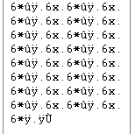

File Size: 172985
Validation Code: 172986

PROCEDURE:

Encryption Key | Normal Text | Encrypted Text
Swordfish | Hello world | ÜÛÞÓ†ÀâÚ¿Û

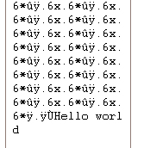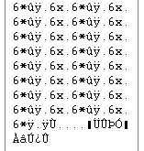

File Size: 172985
(Original Image File) Original Message Encrypted Message
Validation Code: 172986

DECRYPTION PROCEDURE

Decryption is nothing but to extract the original message or text from the encrypted format. In this program, the decryption of the encrypted message can be only possible if the user enters both the ‘Encrypted Key’ and the ‘Validation Code’. There will be an invalid output if your Encryption Key or the Validation Code is incorrect.
By entering the Validation code, the program would seek to the corresponding position in the image file and then decrypt the message using the Encryption key. If an invalid validation code is specified, junk values are obtained.

ALGORITHM:

Step 1: Get the Encryption Key and the Validation Code.
Step 2: Go the Byte position in the Image file using the value specified by the Validation code.
Step 3: Using a ‘for loop’ get a character from the byte position and subtract it from the ASCII value of the encryption key.
Step 4: Increment the Byte position and repeat the above step until the end of the file is reached.
Step 5: The decrypted message is in ASCII values and should be converted into ‘Char’ format to obtain the original message.

CHAPTER 13

APPLICATIONS

Most organizations have invested in significant networks to link together hundreds, if not thousands of computers that have access to data. And almost all organizations have multiple links into and out of the internet

On the other hand, the world seems to be filled with hackers, crackers and industrial spooks of various kinds who are constantly mounting attacks on our networks, our email, our hardware systems and ultimately our data. To finally avoid this we go in for security of data through many methods and one of the methods is my project which gives you a better idea of securing data in an image and without the knowledge of hackers. Some of the application areas are as follows:

APPLICATION AREAS:
- Secured Key Distribution
- Authentication
- E-Commerce
- Medical Data Archival
- Commercial & Military Communications
- Translation & Sharing

CHAPTER 14

FUTURE ENHANCEMENTS

My project is a foundation for a much wider research work that can be done on Data Security from the system side view. This development in the field of security is a must and it is a great project to develop in this subject. It gives you research opportunities for security levels required in protecting the data inside a small image.

Other areas where code can be implemented.

This code works on any file, not only JPG or BMP file. You can try this on any file. You can apply this concept an any compressed file or even in EXE files , PDF etc.

CHAPTER 15

ADVANTAGES

Generally a project is developed on the basis that it should be useful and universally accepted. Advantage is a factor everybody looks for in the project and that makes it possible for that particular project find its place in the market. Some of the advantages are :

- Easy approach for better transfer of data
- Better reliability over other storage techniques
- Low cost factor which is unique
- Securing data in an image without the knowledge of hackers
- No deformation of image
- High – Level security : 2 Level Authentication
- Difficult to be Brute forced.

CONCLUSION

The main purpose of this project was to exchange the most vital and confidential Information among the group without permitting other hackers or intruders from getting to understand what the message to the other person was, thereby weakening the prospectus of the intruder.

A message was embedded in a digital image in a manner that will not arouse any suspicion to any one that there is some message in a code format behind the image. Encryption and Decryption algorithms were used to convert the message into a code format which was later stored in the image. The image could be viewed by anyone, but no one could even know that there is some information stored inside the image.

This project could be used in application areas like commercial and military communications, authentication, e-commerce. In future, it gives great research opportunities for more security techniques and to have security levels in protecting the data inside a small image.

MAIN FORM:

Private Sub Command1_Click()
text1.Visible = True
CommonDialog1.Filter = "JPG Files|*.jpg|Bitmap Files|*.bmp|"
CommonDialog1.ShowOpen
If Len(CommonDialog1.FileTitle) > 0 Then
text1.Text = CommonDialog1.FileName
Else
Exit Sub
End If
End Sub

Private Sub Command2_Click()
text2.Visible = True
If Right(text1.Text, 3) = "jpg" Or Right(text1.Text, 3) = "JPG" Then
CommonDialog1.Filter = "Jpg File|*.jpg|"
Else
If Right(text1.Text, 3) = "bmp" Or Right(text1.Text, 3) = "BMP" Then
CommonDialog1.Filter = "Bitmap File|*.bmp|"
Else
Exit Sub
End If
End If

CommonDialog1.ShowSave
If Len(CommonDialog1.FileTitle) > 0 Then
text2.Text = CommonDialog1.FileName
Else
Exit Sub
End If
End Sub

Private Sub extract_msg_Click()
Form1.Show
End Sub

Private Sub Hide_Msg_Click()
If Len(text3.Text) < 3 Then
MsgBox "Encryption Key should be at least 4 Characters", vbCritical, "User Error 01"
Exit Sub
End If
If text1.Text = "" Or text2.Text = "" Then
MsgBox "Please select the Source Image and Destination Image Location", vbCritical,"User error”
Exit Sub
End If
If text4.Text = "" Then
MsgBox "Enter the secret message", vbCritical, "User Error"
Exit Sub
End If

Dim encryptor
encryptor = Encrypt(text3.Text, text4.Text)
Close #1
FileCopy text1.Text, text2.Text
Text5.Text = FileLen(text1.Text)
Open text2.Text For Binary As #1
Put #1, Val(Text5.Text) + 1, encryptor
Close #1
'Close #3
Text5.Text = Val(Text5.Text) + 4
End Sub

MESSAGE EXTRACTION FORM:

Private Sub Command1_Click()
CommonDialog1.Filter = "Jpg File|*.jpg|Bitmap File|*.bmp|"
CommonDialog1.ShowOpen
If Len(CommonDialog1.FileTitle) > 0 Then
Text1.Text = CommonDialog1.FileName
Else
Exit Sub
End If
End Sub

Private Sub Command2_Click()
If Text1.Text = "" Then
MsgBox "Please select the image file first", vbCritical, "User Error 01"
Exit Sub
End If

If Text2.Text = "" Or Len(Text2.Text) < 5 Then
MsgBox "The length of Encryption Key cannot be less than 5", vbCritical, "User error 02"
Exit Sub
End If
If Text3.Text = "" Then
MsgBox "Validation code is not provided", vbCritical, "User Error 03"
Exit Sub
End If

Clipboard.Clear
Dim validcode01 As Long
Dim validcode02 As Long
Dim extmessage As Byte
Dim dycrypted
Dim i As Long
validcode01 = Text3.Text
validcode02 = FileLen(Text1.Text)
Close #1
Text4.Text = ""
Open Text1.Text For Binary As #1
For i = validcode01 To validcode02
Get #1, i, extmessage
Clipboard.Clear
Clipboard.SetText extmessage

Text4.Text = Text4.Text + Chr(Clipboard.GetText)
Next i
Close #1
decrypted = Decrypt(Text2.Text, Text4.Text)
Text4.Text = decrypted
Exit Sub
End Sub

ENCRYPTION MODULE:

Public Function Encrypt(Key1 As String, txtcode As String)

Dim i, j, k As Integer, thekey
Dim a, b, CryptText As String
On Error Resume Next
If Key1 <> "" Then
thekey = Key1
i = 0
For j = 1 To Len(txtcode)
i = i + 1
If i > Len(thekey) Then i = 1
a = Mid(txtcode, j, 1)
k = Asc(a)
b = Mid(thekey, i, 1)
k = k + Asc(b)
If k > 255 Then k = k - 255
CryptText = CryptText & Chr(k)
Next j
txtcode = CryptText
Encrypt = txtcode
End If
End Function

DECRYPTION MODULE:

Public Function Decrypt(Key1 As String, txtcode As String)

Dim i, j, k As Integer, thekey
Dim a, b, CryptText As String
On Error Resume Next
CryptText = ""
If Key1 <> "" Then
thekey = Key1
i = 0
For j = 1 To Len(txtcode)
i = i + 1
If i > Len(thekey) Then i = 1
a = Mid(txtcode, j, 1)
k = Asc(a)
b = Mid(thekey, i, 1)
k = k - Asc(b)
If k < 0 Then k = k + 255
CryptText = CryptText & Chr(k)
Next j
txtcode = CryptText
Decrypt = txtcode
End If

End Function

MAIN WINDOW / FRAME:

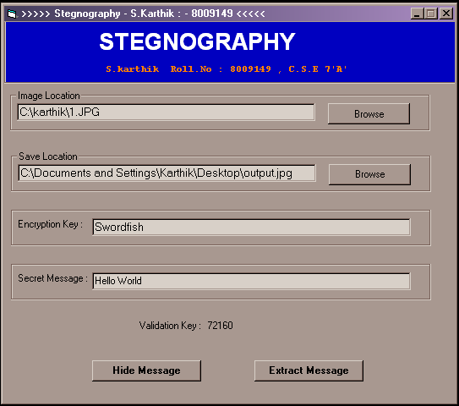

MESSAGE EXTRACTION WINDOW:

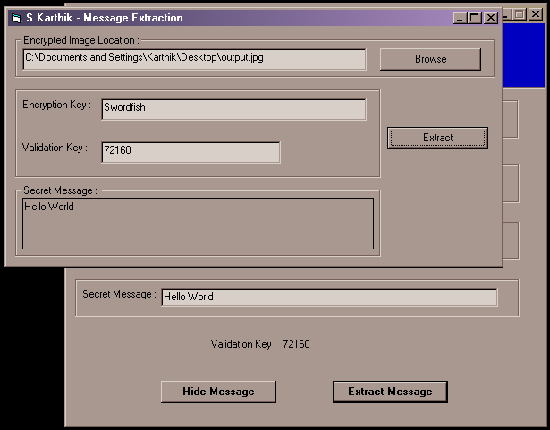

ORIGINAL IMAGE FILE: (21.jpg)

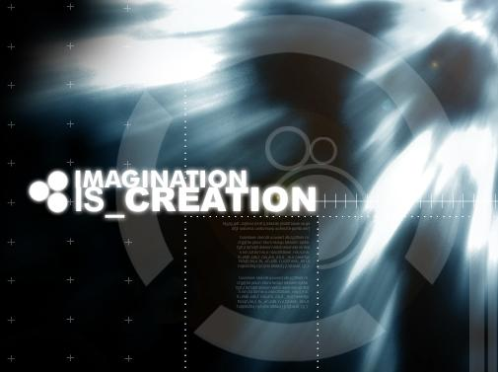

IMAGE IN BINARY FORMAT ( HEX MODE ):

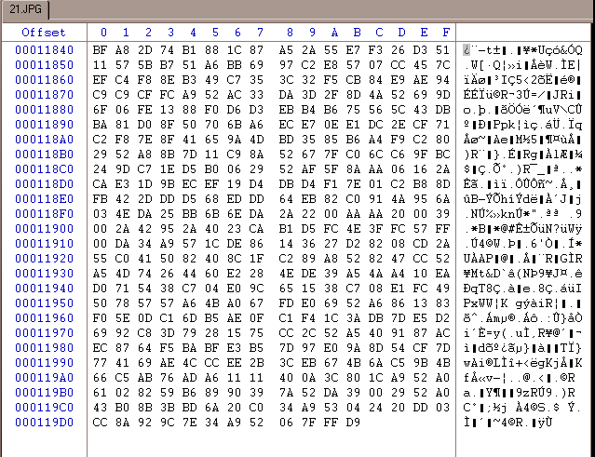

OUTPUT IMAGE FILE: (output.jpg)

OUTPUT IMAGE IN BINARY FORMAT ( HEX MODE):

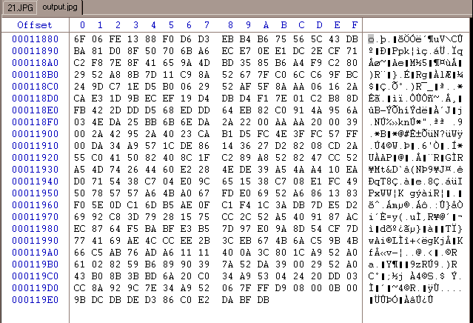
Encrypted Message

BIBLIOGRAPHY

1. APPLIED CRYPTOGRAPHY by Jhon Wiley Sons
2. DATA ENCRYPTION by Leroy Finkel
3. DATA ENCRYPTION by Gerald & R.Brown
4. EXPLORING STEGANOGRAPHY by Johnson & Jajodia
5. www.steg.com
6. www.cryptography.com

